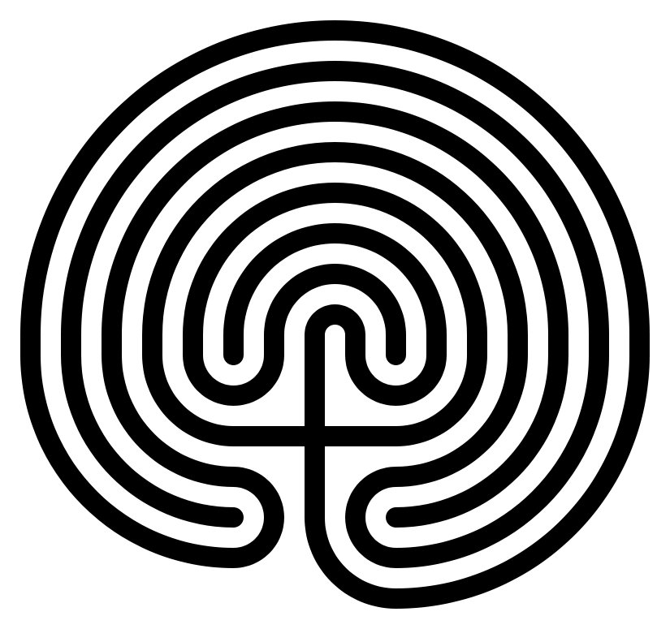

Deborah Yaffee, CH, CN, Veriditas-Certified Labyrinth Facilitator
www.labyrinthlife.com 413-625-2800 labyrinthgal@gmail.com www.riversidehealing.com

